Nguyễn An Phúc – 21IT639

Ôn tập
Câu 1. In the CPU, what is the functionality of the control unit?
A. To decode program instruction
B. To perform logic operations
C. To store program instruction
C.To transfer data to primary storage
Câu 2. The internal components of the processor are connected by _______
A. Processor intra-connectivity circuitry
B. Processor bus
C. Memory bus
D. Rambus
Câu 3. The brain of the computer. This part does the calculation, moving and processing of information?
A. CPU
B. RAM
C. Motherboard
D. Hard Drive
Câu 4. What is the capacity of the ENIAC machine?
A. 2000 additions/sec
B. 3000 additions/sec
C. 4000 additions/sec
D. 5000 additions/sec
Câu 5. The time required to fetch an instruction from memory and execute it is called _____
A. Fetch Cycle
B. Execution Cycles
C. Load Cycle
D. Instruction Cycle
Câu 6. The basic structure of an instruction has ........
A. Register and Opcode
B. Decoder and Accumulator
C. Sequence register and Decoder
D. Opcode and Address
Câu 7. When ever the data is found in the cache memory it is called as _________
A. HIT
B. MISS
C. FOUND
D. ERROR
Câu 8. Consider a machine with a byte addressable main memory of 2^16 bytes and block size of 16 bytes. Assume that a direct mapped cache consisting of 64 lines is used with this machine. How is a 16-bit memory address divided into tag number, line number, and byte number?
A. 7-5-4
B. 8-4-4
C. 6-6-4
D. 6-7-3
Câu 9. How many address bits are required to represent a 32 K memory[1] ?
A. 10 bits
B. 12 bits
C. 14 bits
D. 15 bits
Câu 10. A databased record has 4 fields. FirstName (text up to 10 characters), Surname (text up to 10 characters), DateOfBirth, NumberOfChildren. There are are 100 records. Text = 1 byte per character, Integer = 4 bytes, Real = 4 bytes, Date = 8 bytes, Boolean = 1 byte. How much storage in bytes would this take up? (Including overheads)
A. 3520
B. 352
C. 35200
D. 352000
Câu 11. Which statement is incorrect?
A. SSDs have lower power consumption than HDDs
B. SSDs have lower cost per bit than HDDs
C. SSDs have lower latency than HDDs
D. SSDs have longer lifespan than HDDs
Câu 12. What is the main advantage of using external memory?
A. It is faster than internal memory
B. It is more expensive than internal memory
C. It is more secure than internal memory
D. It has a larger storage capacity
Câu 13. In which IO mechanism, does the processor take the least control on I/O operation?
A. Programmed
B. Interrupt-driven
C. DMA
D. Programmed or Interrupt-driven

Câu 14. In DMA transfers, the required signals and addresses are given by the ______
A. Processor
B. Device drivers
C. DMA controllers
D. The program itself
Câu 15. For the following CPP program, what is the result on the screen when executing the program?
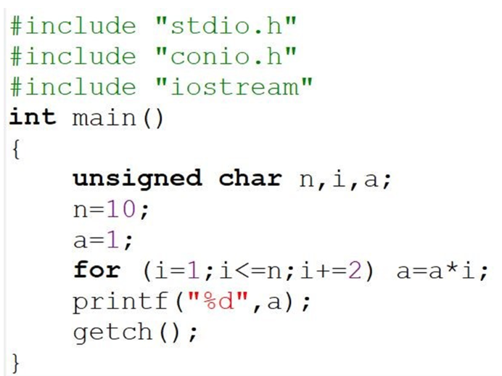
A. 217
B. 177
C. 945
D. 257
Câu 16. For the following CPP program, what is the result on the screen when executing the program?
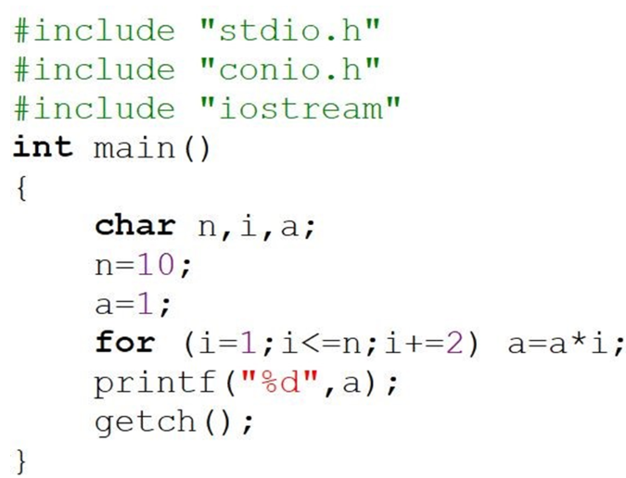
A. -79
B. 177
C. 945
D. 217
Câu 17. When we perform subtraction on -7 and -5 the answer in 2’s complement form is _____
A. 1111
B. 1110
C. 1010
D. 0010
Câu 18. In which addressing mode is the operand value directly specified in the instruction?
A. Immediate
B. Relative
C. Direct
D. Definiti
Câu 19. If a processor clock is rated as 1250 million cycles per second, then its clock period is _____
A. 1.9 * 10^-10 sec
B. 1.6 * 10^-9 sec
C. 1.25 * 10^-10 sec
D. 8 * 10^-10 sec
Câu 20. Assembly language programs are written using
A. Hex code
B. Mnemonics
C. ASCII code
D. Binary code
Câu 21. __________ converts the programs written in assembly language into machine instructions.
A. Machine compiler
B. Interpreter
C. Assembler
D. Converter
Câu 22. Given the following assembly language
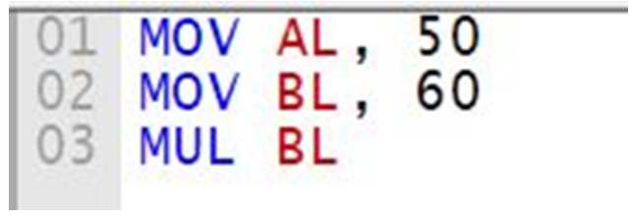
After executing the above program, the AH register has the value (decimal) is:
A. 10
B. 11
C. 12
D. 13

